Appendix G:

The HSP Template Instructions

Contents

Using the Template G-3
Section 1 Establishing Policies G-15
Section 2 Organization, Roles and Responsibilities G-19
Section 3 Countermeasures and Strategies G-22
Section 4 Plan Maintenance G-27
Attachment A: Capabilities Checklist G-30
Attachment B: FTA Top 20 Security Program Action Items for Transit Agencies: Self-Assessment Checklist G-37

Using the Template

Introduction
Transportation providers serving small and rural communities face a number of unique security challenges. Resources are limited, staff is small, and, typically, major security events are not the norm. For these reasons, security planning—especially for catastrophic events—is often set aside as a remote possibility that would divert precious resources from the prevailing, day-to-day need to provide transportation services.

Fortunately, the development of a sound security program can make good business sense if the effort is structured appropriately and targeted specifically to the needs of smaller agencies. Such a program must rely on processes that have cross-applicability to other issues facing agencies and that, therefore, can provide a near-term return on investment. This approach is critical in leveraging scarce transit agency assets, such as the development of “all hazards” emergency response plans to address both security events and natural disasters (e.g., hurricanes). Such an all-hazards approach is the “state of the practice,” representing a practical and cost-effective means of addressing several eventualities with one well-designed methodology. In addition, an all-hazards approach has now been required by recent regulations, discussed in more detail in the text that follows, to introduce uniformity and efficiency in the ways that local, regional, state, and federal agencies plan for and respond to security and other emergencies. The likelihood of agency personnel absorbing and effectively employing such a practice in the event of an emergency is far greater using simple yet effective programs to approach a range of security issues and other hazards.

The template in this document was designed to guide development of a transit agency’s plan that deals with security events that are severe (e.g., a bomb threat) as well as routine (e.g., disturbances on-board vehicles). Fortunately, for transit agencies, many of the basic steps are the same for both types of events (e.g., training new employees in what to look for in a range of situations, providing simple step-by-step policies, making it clear to employees when to involve organizations outside the transit agency, and stressing communications with the dispatcher at all times).

The approach outlined in the document that follows emphasizes the fundamentals:
- Clear agency policies – Dozens of sample policies are offered in this document that transit agencies can use as templates.
- Training new employees in the basics – This training can be done in conjunction with other efforts.
- Communications within the agency – When faced with situations, above all, employees should know what to do, and know when to communicate situations to others within the agency for guidance.
- Communications with outside organizations – Law enforcement, fire, first responders, and emergency organizations near the transit agency have done much of the work and can offer assistance.
- Practicing – Whether in day-to-day operations (including security issues in the daily vehicle inspection sheet) or less frequent events (e.g., emergency evacuation drills), practicing is an important part of a security plan.

Though intended to address security issues primarily, the template is also flexible enough to encompass non-security events; preparation for security events such as terrorism should also help prepare employees and others to respond to more common safety-related events such as severe weather. Therefore, though non-security events are not the focus of the document, opportunities to encompass non-security hazards using security strategies are highlighted.

Project Background

The development of methods for effectively preparing for security events and local emergencies has been an important focus of research in recent years. Organizations such as the Department of Homeland Security (DHS) have developed guidelines for all-hazards responses, including the National Incident Management System (discussed below); this work provided the basic approach for the guidance subsequently developed for smaller agencies that must address these same issues.

These materials, though useful in offering a structure and a foundation for approaching the topic, are not focused specifically on transit issues or on the particular concerns of smaller transportation providers. For this perspective, several other sources, including the materials developed by the Texas Transportation Institute (Higgins, Laura L., Hickman, Mark D., and Weatherby, Cynthia A., Emergency Management Planning for Texas Transit Agencies: A Guidebook, October 1999), were referenced. The Minnesota Department of Transportation provided helpful materials describing how agencies can ensure that security-oriented approaches are integrated successfully into their operations.

The emergency management and security disciplines have matured and restructured in the post–September 11 environment; consequently, updated approaches were necessary. Therefore, to further refine the materials developed by the research team, more current transit-specific research was referenced, including the Ohio Department of Transportation System Security and Emergency Preparedness Plan (SSEPP) template. As part of this research effort, the SSEPP was distributed at an expert workshop of small transportation providers in order to solicit feedback. Overall, participants found most of the document better suited to larger agencies. Industry practitioners, however, found certain structural elements and individual components useful, so these elements were retained.

The Community Transportation Association of America (CTAA) also has produced a number of materials on security and emergency response, particularly information presented at a conference titled “Safety and Security: Transit’s Role in Community Preparedness.” This material was a rich source for resource materials.

Finally, ideas from individual rural transit providers were solicited at an expert workshop and a pilot session during which this document was presented in draft form. Policies, approaches, and other information were collected and incorporated.

National Incident Management System

On February 28, 2003, Homeland Security Presidential Directive 5 was implemented, requiring the implementation of a National Incident Management System (NIMS) to provide a new standard for domestic incident response for all levels of government. In past years, emergency response organizations at state, federal, and local levels used widely divergent means of responding to events; though individual methods may have been effective, coordination among organizations was often complicated. The NIMS approach resolves these issues by establishing a framework for consistent and efficient interaction across agencies.

Consequently, the overall framework of NIMS has been adopted in the plan template described here to ensure that terminology, structure, and contents of the HSP are compatible with the more universal standard used in incident management (this topic will be discussed further in later sections). The overall structure of the NIMS approach—shown below—will be used in Section 4:

- Command and management
- Preparedness
- Resource management
- Communications and information management
- Supporting technologies
- Ongoing management and maintenance

The concept behind NIMS is reflected in the plan outlined in this document. Both are intended to be flexible and scalable approaches to a range of hazards. Since most serious incidents require responses from multiple agencies, use of a common standard will generate the most efficient, coordinated response across multiple agencies. The presidential directive also specified that federal agencies must require adoption of NIMS by October 2004 as a condition of receiving federal preparedness assistance (such as grants).

The DHS provides a tool at www.fema.gov/NIMCAST that describes, by the categories listed above, the specific measures and capabilities that jurisdictions and agencies must develop and incorporate into an overall system to enhance their ability to prepare for and respond to incidents. Many of the activities are appropriate for first responders (e.g., law enforcement and fire departments). Transit agencies play a role in being part of the response and performing activities within the overall framework of responding to incidents.

This tool allows the user to select each of the several federally mandated elements of NIMS and describe the agency’s progress toward completing these NIMS requirements. The tool presents a list of NIMS requirements in this area. Again, the tool is intended to be used by agencies receiving federal grants, so not all elements will apply to transit agencies, who may take a small, supporting role in many response efforts.

As an example, a key measure required by NIMS is the completion of an Emergency Operation Plan (EOP) - “Each jurisdiction develops an EOP that defines the scope of preparedness and incident management activities necessary for that jurisdiction.”

Within the tool, the following NIMS requirements are presented. As with many of the requirements, by completing the HSP and the necessary policies and work that goes into the HSP, the agency should be compliant with the EOP requirement.

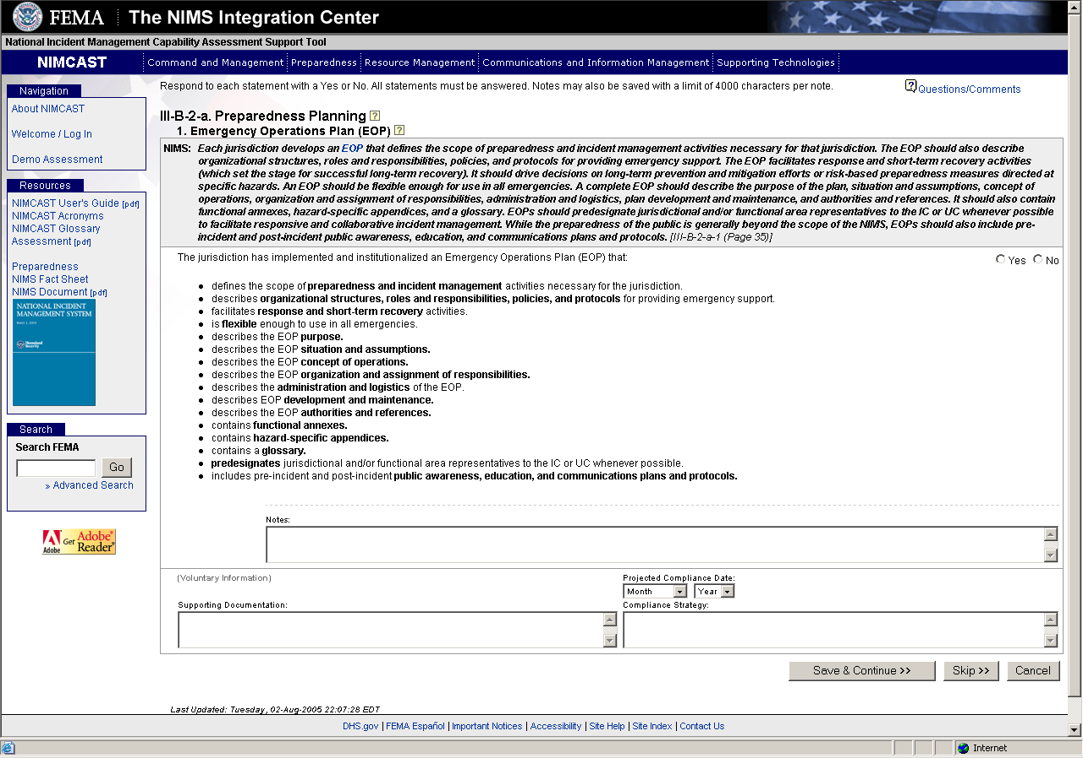
MINIMUM NIMS COMPLIANCE ACTIVITIES TO BE ACHIEVED DURING FY 2005

State- and territory-level efforts to implement NIMS must do the following:

- Incorporate NIMS into existing training programs and exercises;
- Ensure that federal preparedness funding supports state, local, and tribal NIMS implementation;
- Incorporate NIMS into EOPs;
- Promote intrastate mutual aid agreements;
- Coordinate and provide NIMS technical assistance to local entities; and
- Institutionalize the use of the incident command system.

At the state, territorial, tribal, and local levels, jurisdictions should support NIMS implementation by:

- Completing the NIMS Awareness Course: "National Incident Management System (NIMS), An Introduction" IS 700. This independent study course developed by the Emergency Management Institute (EMI) explains the purpose, principles, key components and benefits of NIMS. The course is available on the EMI web page at: http://training.fema.gov/EMIWeb/IS/is700.asp.

- Formally recognizing NIMS and adopting NIMS principles and policies. States, territories, tribes, and local entities should establish legislation, executive orders, resolutions or ordinances to formally adopt NIMS. Go to http://www.fema.gov/nims and click on Tools and Templates for examples.

- Establish a baseline by determining which NIMS requirements you already meet. State, territorial, tribal, and local entities have already implemented many of the concepts and protocols identified in NIMS. As gaps in compliance with NIMS are identified, states, territories, tribes, and local entities should use existing initiatives such as the Office for Domestic Preparedness (ODP) Homeland Security grant programs, to develop strategies for addressing those gaps.

- Establishing a timeframe and developing a strategy for full NIMS implementation. States, territories, tribes, and local entities are encouraged to achieve full NIMS implementation during FY 2005. To the extent that full implementation is not possible during FY 2005, which ends on Sept. 30, 2005, federal preparedness assistance must be leveraged to complete NIMS implementation by Sept. 30, 2006. Beginning FY 2007 (Oct. 1, 2006), federal preparedness assistance will be conditioned by full compliance with NIMS. States should work with the tribal and local governments to develop a strategy for statewide compliance with NIMS.

- Institutionalizing the use of the Incident Command System (ICS). If state, territorial, tribal, and local entities are not already using ICS, you must institutionalize the use of ICS (consistent with the concepts and principles taught by the DHS) across the entire response system. See Terms and Definitions: Institutionalizing the Use of ICS on the NIMS homepage at http://www.fema.gov/nims.

FY 2006 and FY 2007 Requirements:

In order to receive FY 2006 preparedness funding, applicants will need to certify as part of their FY 2006 grant applications that they have met the FY 2005 NIMS requirements.

For questions, follow up at NIMS-Integration-Center@dhs.gov.

The Hazard and Security Plan

A hazard and security plan (HSP) is a template for producing a security plan. It includes documents, responsibilities, training assignments, and related materials. The name Hazard and Security Plan is intended to stress the applicability of the document as a tool to address all types of hazards (including security events), using an “all-hazards” framework—that is, an approach flexible enough to be applied to several types of events.

Example Used in this Template

This template guides the user through the HSP of a fictitious agency (Your Community Transit). All of the policies and materials that are specific to Your Community Transit are printed in ALL-CAPS, BOLDFACE ITALIC.

The use of an example in this document offers guidance to agencies completing their own HSP; each of the sample policies and approaches may be used in completing the HSP of actual agencies. It should be noted that, in order to demonstrate the completion of all aspects of security and other hazard planning activities, a fictitious agency was selected that is not typical. In particular, it is subject to a wide range of extraordinary hazards requiring comprehensive and wide-ranging programs to manage them. These extraordinary hazards are described so the individual who is using this document as a guide can choose from a menu of items and select policies and activities that fit their own agency. Nearly all agencies will be subject to far fewer hazards that the example agency used in this document. Include only those hazards, policies, procedures, and information that are suited to your agency.

Agencies using this template should start by saving the document as a new file, reviewing the document, then deleting YOUR COMMUNITY TRANSIT information and inserting their own name. The agency should then add their own organization-specific information, which, in most cases, will be less extensive.

The process of creating the HSP can be broken down into sections, each with several component parts. Assembling individual parts that fit the transportation organization (under an overall policy “umbrella” suited to the organization) will yield a plan that is focused appropriately. The document that follows offers guidance on elements that should be included in the HSP itself, as well as dozens of materials that will help to implement the HSP. Not all examples or materials will be suited to every organization. This HSP should be viewed as a resource and a framework into which organization-specific information can be organized—rather than a rigid plan that describes every situation. Organizations may wish to include some pertinent elements, modify other materials to suit their needs, and omit others, as appropriate. The end document should be a living, usable plan, so it is important that it be appropriate to the organization.

This document will show the user how each of the following activities is to be accomplished, using examples and suggestions:

PREVENT

Provide Technology to Protect System
- Provide equipment, as appropriate, to protect the agency (radio, dispatch, alarms, fences, locks, cameras, automatic vehicle location [AVL])
- Design systems to be reliable and interoperable with appropriate backup
- Understand how the equipment will function in the event of a disaster

Increase Training and Awareness
- Implement procedures to safeguard agency employees, passengers, vehicles, facilities, and other assets
- Develop policies to increase awareness and understanding of these procedures
- Train employees on these policies
- Establish a communication network that is linked to the county and local plan

MITIGATE
Identify Needs
- Identify areas to reduce the probability and severity of damage, asset loss, or human consequences
- Identify areas to contain consequences, where appropriate
Develop Solutions
- Develop agency policies that limit consequences of security events
- Apply technology (e.g., alarms or communication devices) to minimize effects of incidents that occur
- Provide training to employees (e.g., training for operators to manage security issues) to handle situations

PREPARE

Identify Participants
- Identity transit system participants (contact lists, emergency numbers, emergency protocols, agency assets)
- Prepare and coordinate participants (security surveys, employee and management training in security)
- Contact outside participants (county emergency coordinator, local fire, police, emergency medical services [EMS], volunteer organizations, other transit agencies)
- Develop mutual aid agreements

Establish Communications
- Develop master emergency lists
- Develop mobilization tools
- Provide emergency contact lists
- Plan for tracking employees, passengers, vehicles, and supplies
- Develop written communication plans

RESPOND

Identify Assets
- Develop an inventory of physical transit assets that need to be protected (work with insurance agency)
- Identify non-physical assets that must be maintained in an emergency (transit provides a ‘lifeline’ to the community)
- Develop a list of resources that the transit agency can provide in an emergency (vehicles, communications equipment, personnel)

Respond to Events
- Develop tools for response to security events and emergencies
- Develop a chain of command for emergencies and succession plan
- Develop backup procedures for key agency assets and information
- Develop public information procedures
- Coordinate with county emergency coordinator

RECOVER

Assess

Develop procedures to assess impacts to agency resources
- Develop tools for documenting the expenses incurred while dealing with an event
- Develop tools for recording resource needs identified as a result of the incident
- Implement procedures for reviewing preparation plans for hazard and security events

Plan for the Future

Identify agency needs to adjust long-term goals

Identify agency needs to adjust finances and budgets
- Identify agency needs to build in redundancies
- Identify agency needs to increase documentation

Implement “lessons learned” with shared processes with the county emergency coordinator or agency emergency response personnel

This document will describe methods and tools that will enable agencies of different sizes and types to develop policies to achieve the above items and the following goals:

- Developing a coordinated program to ensure that the transportation system, local emergency responders, and local planning agencies work together to identify vulnerabilities to acts of terrorism and other emergencies.
- Encouraging clear definition of security and emergency response roles and responsibilities, both within the transportation system and with local responders.
- Supporting implementation of procedures compliant with NIMS.
- Promoting greater consistency in local, state, and federal requests for program funding, training, and exercising involving public transportation.
- Identifying and reviewing the role of public transportation in community plans.
- Developing an inventory of available equipment and resources that the transportation system can contribute to community emergencies.
- Establishing joint policies and procedures for evacuation and in-place protection in the event of contamination by chemical, biological, or radiological agents.
- Identifying how transit personnel should support scene management requirements at a major incident, including staging for mass casualties, search and rescue, and debris removal.
- Identifying how transit can support management of medically vulnerable populations during major emergencies.

Building an Agency HSP by Using the Template

This document contains a template for HSP development. The template will help transportation programs and transit agencies design and implement a procedure that will accomplish each of the four core functions shown in the diagram below.

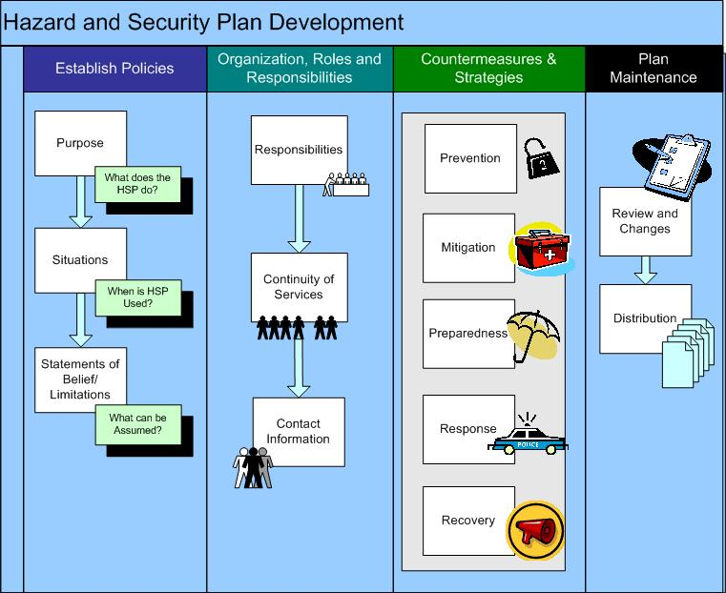

Section 1
Establishing Policies

Purpose

The Hazard and Security Plan (HSP) is designed to address both routine and emergency security events—from minor incidents such as disruptive behavior on-board vehicles to major events such as bomb threats. The policies designed and documented in the plan will have cross-applicability and will enable the organization to respond to and mitigate other events, such as safety incidents and natural disasters. This plan addresses minor or major disruptions as well as damage to physical equipment. The plan is designed to help the agency responders respond to and recover from security or other unexpected events. For serious events, this may include breakdown of vehicles; communications interruptions; inability to locate staff; destruction of records, equipment, and supplies; inability of staff (who may themselves be victims) to cope with loss; and confusion among personnel. For routine security events, examples could include staff injuries (e.g., from workplace violence) or damage to security equipment (e.g., fences or alarms).

The first step in developing the HSP is to identify what the document is intended to do. The organization completing this template should set forth a succinct description of the purpose of the plan in this section. The plan, and its stated purpose, must be sufficiently flexible to encompass a range of situations of various degrees of severity.

Section Instructions. Complete the template blanks in this section. Modify or replace the ALL-CAPS, BOLDFACE ITALIC TEXT, as needed, to reflect the needs of your organization.

Situation

The HSP is not designed to cover all situations. For maximum usefulness, the plan should focus specifically on a few of the most likely emergencies and routine security events. Identifying likely hazards will help the organization plan for the most probable occurrences. The plan, however, will result in a core set of policies and procedures that apply to almost any situation. The section defines situations for which the plan will be enacted, and identifies the likely emergency management and other needs that will arise as a result.

Section Instructions. The sample provided includes many possible hazards for purposes of illustration. Insert in the table a brief list of hazards that affect your agency, concentrating on the few (say, three or four) most relevant rather than on a long list of every possible hazard that may arise. The table of hazards should include related facts about why these hazards were selected, how likely they are, and whether they have occurred in the past.

Other References. The HSP is only as good as its underlying planning. It is important to prepare for the full range of hazards that may affect the agency. This involves, first, designing a core set of practices that address a range of normal and emergency circumstances. Second, it is critical to plan realistically for those hazards that are most likely to occur. Supplement the template in this section using other resources such as the following to ensure that the plan encompasses all key hazards.

- Work with local law enforcement to take advantage of locally developed security information. The sheriff’s office or police department will have unique insights into (a) routine regionwide security issues that may affect the agency (recent vehicle thefts, vandalism, or burglaries in other parts of the town or county), as well as (b) intelligence on more serious security issues that the agency should be considering (e.g., concerns about security threats to the local nuclear power plant that could affect the agency’s service region).

- Review your state and local emergency plans. States and regions often have the resources to perform detailed threat assessments. A good starting point for identifying local hazards is to understand what hazards concern state and local planners.

- Work with local emergency managers to understand overall hazards to the community. Transit operators may be more focused on historical incidents that the transportation organization has faced. Local emergency managers can supplement this information with a broader understanding of regionwide hazards. State agencies are a good place to identify available resources. Contact information and the website addresses of all state emergency management offices can be found at the following website: http://www.fema.gov/fema/statedr.shtm.

- Use other reference materials. As just one example, FEMA has developed a series of “How To” guides to help local organizations identify hazards. Understanding Your Risks: Identifying Hazards and Estimating Losses (FEMA 386-2) provides step-by-step information and worksheets to help localities identify hazards. It can be found here: http://www.fema.gov/fima/howto2.shtm. State planning materials and model templates for developing lists of potential hazards are also available. ,

- Discuss hazards and solutions with other local stakeholders. A number of local organizations may have already done assessments that could be useful. For example, the county public works department or local utility companies may have hazard assessments that they will share or discuss with you. These organizations would also have information on the anticipated disruption to utilities or other services if such hazards were to occur. Details on power, water, or communication outages are important to transportation organization planning.

- Map out hazards. In addition to listing situations or likely hazards, it is often useful to make a map of potential hazards that have been identified, including areas such as nearby targets (e.g., a larger city in the vicinity, a power plant, or a military base) or areas where natural or other hazards may occur (e.g., a span of river that frequently floods or a roadway in which accidents commonly occur). Each should be labeled, highlighting the nature of the potential hazard.

- Review existing checklists. To get a sense of where your agency stands, and to get ideas for improvements, complete the Capabilities Checklist in Attachment A and the FTA Top 20 Security Program Action Items for Transit Agencies in Attachment B.

Statements of Belief and Limitations

This section describes conditions that would be present in the event of a hazard or security event and that may affect the agency’s response in a positive or negative manner. For example, an agency might assume that the local fire department will be available to respond. The section delineates those events that the transportation organization will manage on its own and those that it will handle with the help of outside agencies. It also outlines those events that the transit agency is not equipped to manage.

Assumptions could include information about topics such as the following, any of which may affect the agency’s ability to handle emergency events:

- Ridership, particularly special requirements (e.g., persons with disabilities or elderly patrons)
- Probability of occurrence and the likely impact of selected hazards
- Resource limitations affecting an agency’s abilities to respond to specific hazards
- Circumstances that would compel a transportation provider to seek assistance from other organizations (including government and private entities)
- Expectations concerning the cooperative effort to be provided by response agencies

Section Instructions. Complete the blanks in the list of assumptions provided. Delete those that do not apply. The list of assumptions need not be lengthy; it is acceptable to have only two or three assumptions in this section. Modify those that will be included to reflect your particular organization and community details. Other assumptions that may be included in this section are listed in the resource materials provided.

Other References

The following documents offer examples:

Section 1 – Establish Policies
File Name | Summary Description | Source
Assumptions - City of Puyallup Washington.doc | Assumptions (statements of belief and limitations) for a locality | Puyallup, Washington
Assumptions related to terrorism - Florida.doc | Guidance for organizations located in Florida in developing terrorism-related assumptions (statements of belief and limitations) | State of Florida
Plan Purpose - City of Puyallup Washington.doc | Sample emergency plan purpose | Puyallup, Washington
Plan Purpose - Port Arthur Transit Texas.doc | Sample emergency plan purpose | Port Arthur, Texas
Plan Purpose – Vermont model.doc | Sample emergency plan purpose – taken from state guidance (model plan development) | State of Vermont
Situation – City of Tumwater.doc | Sample emergency plan situation for a city | City of Tumwater, Washington
Situation and Assumptions - AACOG & Golden Crescent.pdf | Examples of statements of beliefs and limitations (assumptions) from two transit agencies | Golden Crescent Transit and Alamo Coordinated Transit

Section 2
Organization, Roles and Responsibilities

Overall Responsibilities

This section of the agency’s HSP should outline the organizational structure and include a brief statement of what needs to happen if a hazard occurs. This section should include a listing of necessary tasks and the corresponding personnel responsible for those duties. When two or more organizations perform the same kind of task, one organization should be given primary responsibility and the other(s) should be given a supporting role. This section should also include information on the role to be played by outside agencies.

This plan delineates vital tasks. The intent is to provide guidance on how to implement the plan—no matter who is available before and after the situation erupts. Attention should be paid to who will act as a backup if key personnel are not available.

Section Instructions. Complete the matrix in this section to provide a quick reference of responsibilities and the corresponding individuals designated to perform each function. If preferred, similar information can be provided using a brief paragraph or an organization chart instead. These are overall responsibilities for key agency security and emergency situations. More detailed daily, weekly, monthly, quarterly, and annual prevention, mitigation, preparedness, response, and recovery tasks are discussed in the section on countermeasures.

Specify a primary and a backup individual, as outlined in the section on continuity (in case the primary individual is not available during an emergency). Be sure that this section is consistent with the organization’s plan for continuity.

Continuity of Services

In order to manage a security incident—whether a terrorist event or a minor security situation such as vandalism—the transportation organization must have a plan for contingency situations in which the designated resources (particularly personnel) are either unavailable or unable to fulfill their emergency functions. The primary concern is for personnel who cannot carry out their assigned emergency duties, but the plan should also include contingency measures in case certain facilities, vehicles, or infrastructure elements are damaged or destroyed.

The agency should develop a continuity of operations plan that identifies critical processes and functions that need to be recovered and sustained. The plan should identify personnel and procedures that are necessary to ensure continuity of all critical functions. Typical elements include the following:
- Designating lines of succession and delegating authority for the successors
- Developing procedures for the relocation of essential departments
- Developing procedures to deploy essential personnel, equipment, and supplies
- Establishing procedures for backup and recovery of computer and paper records

Especially important is the preservation of records necessary to ensure the operation of the system in the event of a security incident (e.g., theft or arson) or other hazard (e.g., flood). In this section, the organization should set forth how records will be protected or duplicate records made available, with particular attention paid to storage provisions and maintenance.

More information is available on this topic from FEMA, which has developed a template for detailed planning on topics such as backup plans for existing facilities (power, communication, recordkeeping, and computerized functions). See http://www.fema.gov/onsc/dhscoop.shtm.

Section Instructions. Specify backup plans for administrative, maintenance, and dispatch facilities in case primary facilities become unusable. Designate plans for the preservation of backup copies of records, including computer media. Finally, describe the plan for succession of transit personnel in case individuals are not available to respond in an emergency.

Contact Information

Section Instructions. Complete the matrix of contact information for each agency staff member, as well as for key external personnel. This matrix should be kept current as agency and other personnel change. Phone numbers and other information should be checked at least once a quarter to ensure that they are current.

Other References

The following documents offer examples:

Section 2 – Organization, Roles and Responsibilities
File Name | Summary Description | Source
Driver Memo.doc | Sample memo to employees soliciting their participation in emergency response activities | John Sorrell
Emergency Participation Notification.doc | Letter for employees explaining their obligations to respond to certain emergency events. This requirement is explained to and agreed upon by all new employees. | Mountain Line Transit, West Virginia
FTA Threat Level Recommendations.doc | FTA’s Transit Threat Level Response Recommendations | FTA
Threat Level Orange Memo.doc | Threat Level Orange memo | Mountain Line Transit, West Virginia
Threat Level Orange Poster.pub | Poster that notifies passengers of the alert level | Mountain Line Transit, West Virginia
Threat Level Yellow Memo.doc | Threat Level Yellow memo | Mountain Line Transit, West Virginia

Section 3
Countermeasures and Strategies

Previous sections have outlined how an organization should document the overall structure of its security and hazard approach (policies, organization, and roles) and identify major hazards that may arise. Organizations should use this section to document key procedures and solutions to address these hazards.

This section outlines the activities that a transit agency will perform in the five elements of emergency management:

- Prevention
- Mitigation
- Preparedness
- Response
- Recovery

In the following pages, information is divided into these five phases of emergency management. The security policies and procedures are summarized in table format at the beginning of each subsection (Prevention, Mitigation, Preparedness, Response, and Recovery) and then explained in more detail.

Section Instructions. This section offers a number of sample activities and supporting materials that will help the agency set up a plan. Not all of the sample activities will be relevant for all agencies. Each agency should select those that are relevant. Each activity should be modified to meet the needs of the agency. These activities may be components of larger agency policies (as an example, a copy of the security checklist is included; such items could be listed on a daily pre-trip inspection sheet). Complete the information on each summary table, including the frequency of the activity, responsibilities, and description. For each policy, complete any relevant information about the security or emergency management activity.

Other References

The following documents offer examples:

Section 3 – Countermeasures and Strategies
File Name | Summary Description |  | Source
01 – Prevention
Visitor Sign-in Sheet.doc |  | Sign-in sheet to manage visitors given entry to the facility |  | HSP
02 – Mitigation
Hazard Assessment Worksheets.pdf |  | Hazard assessment tools assembled by FEMA |  | FEMA
Hazard Assessment Worksheets - Instructions.pdf |  | Hazard assessment tools assembled by FEMA |  | FEMA
State of Kentucky – Possible Hazards.doc |  | Listing of hazards and definitions assembled by the state of Kentucky |  | State of Kentucky
Vermont Sample Hazards.doc |  | Listing of hazards and definitions assembled by the state of Vermont |  | State of Vermont
03 – Preparedness
MOU memo.doc |  | Document used to commit resources and assistance to the local emergency management agency |  | John Sorrell
Mutual Support Resources.doc |  | Data sheet to collect and maintain information on potential mutual support resources (primarily transportation assets) |  | John Sorrell
NIMS implementation plan template.doc |  | Template to guide organizations in implementing new DHS requirements for use of the National Implementation Management System |  | DHS
Pre Event Checklist small.doc |  | An agency/management checklist for pre-event activities and for planning activities. It is in a small format. |  | John Sorrell
Pre Event Checklist.doc |  | An agency/management checklist for pre-event activities and for planning activities. It is in a regular format. |  | John Sorrell
Required on board emergency supplies.pdf |  | Agency policy for on-board emergency supplies |  | Connect Transportation, Gulf Coast Center
Severe weather action plan.pdf |  | Plan intended for maintenance department |  | DART
Social Service Agency.doc |  | Data sheet to collect and maintain information on social service agencies and their points of contact |  | John Sorrell
Transit Terrorism Resource Guide.pdf |  | Florida Public Transportation Anti-Terrorism Resource Guide |  | National Center for Transit Resource
Vehicle Inventory List (available for emergency response).pdf |  | Vehicle inventory list (available for emergency response) |  | Mountain Lion Transit
04 – Response
Blank Checklist.doc |  | Blank template for an agency checklist |  | John Sorrell
Bomb threat checklist - Harris County.pdf |  | Checklist for gathering information for a phone-in bomb threat |  | Houston METRO
Bomb threat procedures - Harris County.pdf |  | Procedures for managing a bomb threat |  | Houston METRO
Chemical & Biological Hazard Procedure.pdf |  | Chemical and biological agent response plan |  | Houston METRO
Critical incident management for first responders.pdf |  | Checklist that first responders can follow |  | New York City Transit
Critical information from first responders.pdf |  | Critical information that should be gathered from first responders |  | FTA
Dispatcher notification sheet.pdf |  | Information that should be collected by a dispatcher upon notification of a situation |  | FTA
Driver Recall Roster.doc |  | Potential format for a driver roster with critical recall information |  | John Sorrell
Emergency response checklist - MLT.pdf |  | Procedures for an emergency in checklist format |  | Mountain Lion Transit
Emergency Response Procedures - After Hours.pdf |  | Emergency response procedures to be used after normal business hours |  | Mountain Lion Transit
Emergency Response Procedures - Normal Hours.pdf |  | Emergency response procedures to be used during normal business hours |  | Mountain Lion Transit
EmPrepPlanMod.doc |  | Emergency preparedness materials focused on transit |  | Minnesota DOT/Office of Transit
ER SOP & Checklist.doc |  | Standard operating procedures and checklist |  | John Sorrell
ER SOP small.doc |  | This agency’s emergency response standard operating procedures in a small format to fit in a 5 ½ by 8 ½ binder |  | John Sorrell
ER SOP.doc |  | This agency’s emergency response standard operating procedures in a small format to fit in an 8 ½ by 11 binder |  | John Sorrell
Evacuation Shelter Loc.doc |  | Data sheet to collect and maintain information on shelters |  | John Sorrell
Event Checklist small.doc |  | A manager’s checklist for an actual event, crisis or response. It is formatted to fit in a 5 ½ by 8 ½ binder |  | John Sorrell
Event Checklist.doc |  | A manager’s checklist for an actual event, crisis, or response |  | John Sorrell
First Responder List.pdf |  | List of first responders to maintain during an emergency to track personnel |  | Mountain Lion Transit
Incident Command.doc |  | Data sheet to collect and maintain information on incident command post and key personnel |  | John Sorrell
Maintenance Vendor.doc |  | Data sheet to collect and maintain information on maintenance vendors |  | John Sorrell
Media relations during crisis.pdf |  | Tips for communicating with the media |  | FTA
Mobilization & Resource List of Available Personnel and Equipment.pdf |  | Data sheet to collect and maintain information on responders and resources during an actual emergency |  | Mountain Lion Transit
No fare service policy during emergency.pdf |  | Policy for not collecting fares during a declared emergency |  | DART
Press Release Listing.pdf |  | Sample prepared press release for use during an emergency |  | Mountain Lion Transit
Radio procedures.pdf |  | Guidelines for normal and emergency use of radio |  | Connect Transportation, Gulf Coast Center
Route Checklist & Emergency Drop Point.pdf |  | Predetermined emergency drop points for use during an emergency |  | Mountain Lion Transit
Standard Protocols for Suspicious Items.pdf |  | FTA’s guidance Standard Protocols for Managing Security Incidents Involving Surface Transit Vehicles |  | FTA
Transit Response to City Evacuation.pdf |  | One-page document explaining the protocol for transit operations should the city of Pittsburgh need to be evacuated. Document is a good example of a brief overview that can be distributed to employees for reference. |  | Port Authority of Allegheny County and City of Pittsburgh
Vehicle Accident - Collision policy.pdf |  | Vehicle Accident/Collision Procedures |  | Connect Transportation, Gulf Coast Center
Vehicle Data Sheet.doc |  | A format to maintain critical information on deployed vehicles |  | John Sorrell
05 – Recovery
Vehicle & Equipment record form.pdf |  | Vehicle and equipment record form |  | Brazos County Inter-jurisdictional Emergency Management Plan

Section 4
Plan Maintenance

Section 4 of your HSP should contain details of how the organization keeps up its plan over time, from the initial implementation to reviews and updates. This section should describe how to keep other documents necessary to the operation of the organization available should a security event occur.

Review and Changes

The HSP should be reviewed periodically—at least every 6 months to a year. The specific agency requirement for review of the document should be stated in this section. In addition, this section should include provisions for how this review is to occur, specifically the following factors:

- Identifying areas to update
- Determining completeness
- Reassessing roles and responsibilities
- Reviewing factual information (especially names and phone numbers included in the plan)
- Reevaluating employee knowledge and awareness (training assessments, for example)
- Revising programs and procedures included in the HSP

In addition to regular, periodic reviews, certain events such as the following may require revision to the HSP:

- The addition of new members inside the organization and outside the organization who have specific roles outlined in the HSP (e.g., a new general manager or a new local fire chief)
- New operations or processes that affect the HSP (e.g., a new bus line)
- New or renovated sites or changes in layout (e.g., a new bus garage or office building)
- Changes with outside agencies, new suppliers, vendors, etc. (e.g., a new memorandum of understanding, or MOU, signed with the local sheriff’s department)

A specific individual should be tasked with keeping the HSP up to date by conducting periodic reviews (at least annually, or as dictated by circumstances). Following use of the HSP in emergency situations (a major security event, a natural disaster, or a training exercise), this individual will review how the organization actually responded versus the procedures outlined in the plan. The designated individual should then identify areas that can be improved or adjusted in the plan to ensure more effective responses in the future.

Section Instructions. Specify the person in charge of the development and maintenance of this plan, the schedule or frequency of reviews and updates, and possible reasons for updates or revisions to the plan. Updates are recommended every 6 or 12 months; if possible, they should be scheduled to precede specific events that are most likely to trigger use of the plan (tornado season, hurricane season, etc.).

Distribution

The HSP should be distributed to all personnel who will be directly involved with or affected by its contents. However, some individuals may need to receive only particular sections of the HSP, its updates, or related policies.

Section Instructions. Specify the personnel who will receive a copy of this plan.

Other References

The following document offers examples:

Section 4 – Plan Maintenance
File Name | Summary Description | Source
ERP - Quarterly update procedures.pdf | Procedures for updating plan quarterly | Mountain Lion Transit

Attachment A: Capabilities Checklist

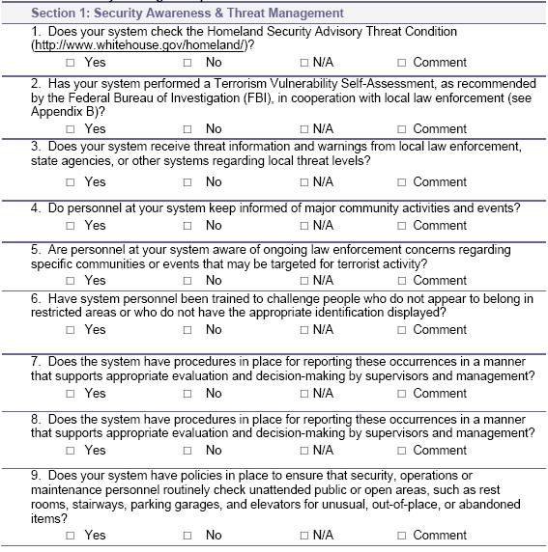
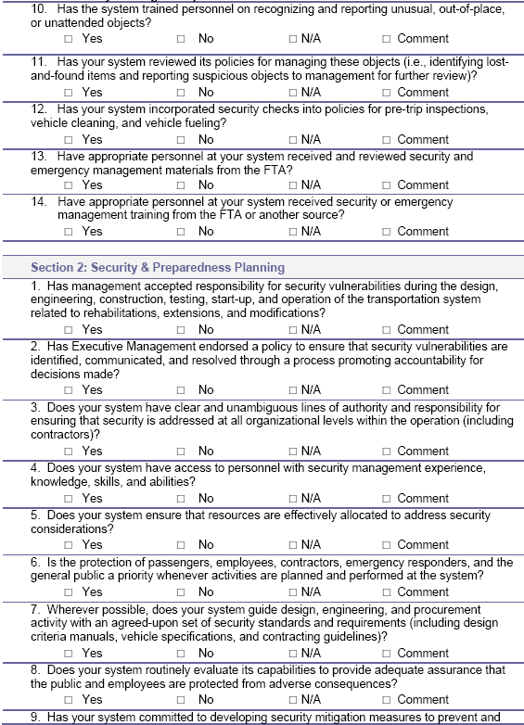
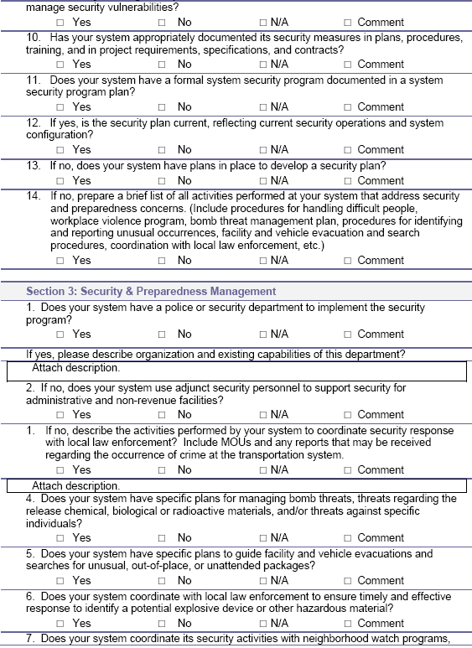
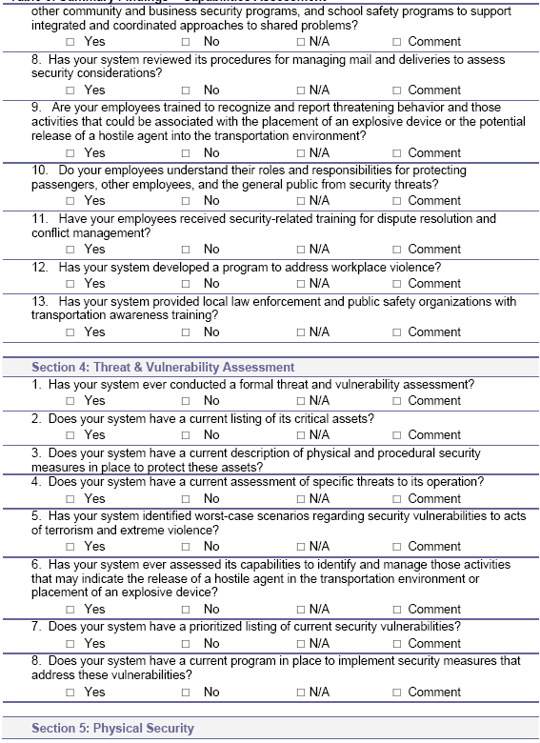
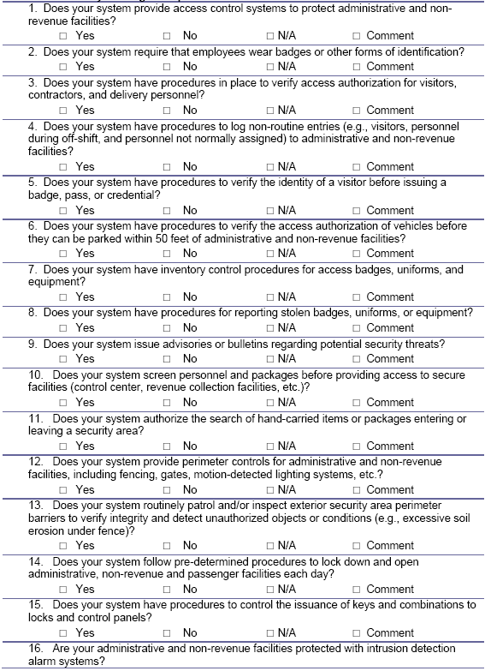
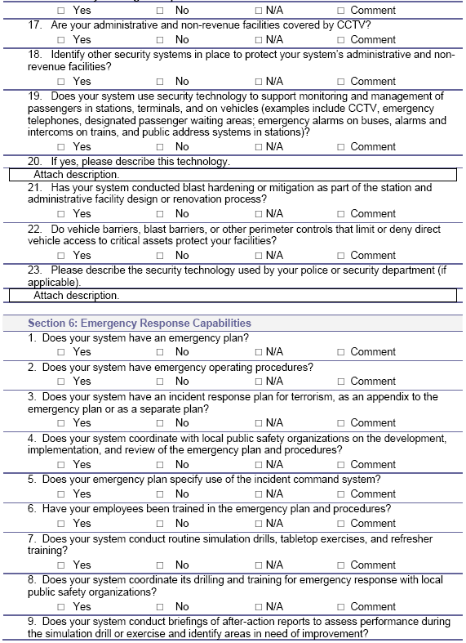
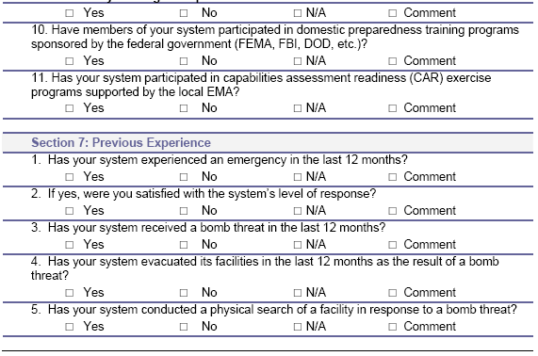
Attachment B: FTA Top 20 Security Program Action Items for Transit Agencies: Self-Assessment Checklist

Notice: This document is disseminated by the Department of Transportation in the interest of information exchange. The United States Government assumes no liability for its contents or use thereof.

Management and Accountability
1. Written security program and emergency management plans are established.
Baseline Practices:
 Does a System Security Plan exist?
 Does an Emergency Management Plan exist?
 Do standard and emergency operations procedures (SOPs/EOPs) for each mode operated, including operations control centers, exist?
Exemplary Practices:
 Do Continuity of Operations Plans exist?
 Does a Business Recovery Plan (administration, computer systems, operations, etc.) exist?
2. The security and emergency management plans are updated to reflect anti-terrorist measures and any current threat conditions.
Baseline Practices:
 What is the date of the latest update?
 Are security plans reviewed at least annually?
 Are reviews and changes to the plans documented?
 Does the plan now include weapons of mass destruction protocols?
3. The security and emergency management plans are an integrated system security program, including regional coordination with other agencies, security design criteria in procurements and organizational charts for incident command and management systems.
Baseline Practices:
 Are emergency management plans integrated with the regional emergency management authority plans?
 Do management & staff participate in planning and conducting emergency security activities (e.g., drills, committees, etc.)?
 Does management coordinate with the FTA regional office?
 Are mutual aid agreements with other regional public agencies (e.g., local government, fire, police, other transit agencies, etc.) approved and signed?
 Does an inter-departmental program review committee exist and address security issues?
Exemplary Practice:
 Is security design criteria/CPTED included in system security program plan?
4. The security and emergency management plans are signed, endorsed and approved by top management.
Baseline Practices:
 Is there a policy statement emphasizing the importance of the security plan?
 Is the security plan approved and signed by the top official?
5. The security and emergency management programs are assigned to a senior level manager.
Baseline Practices:
 What are the name and title of the security program manager?
 Is there a current organizational chart identifying the reporting structure for the security program manager?
6. Security responsibilities are defined and delegated from management through to the front line employees.
Baseline Practices:
 Are security plans distributed to appropriate departments in the organization?
 Do regular senior and middle management security coordinating meetings occur?
 Do informational briefings occur whenever security protocols are substantially updated?
 Are lines of delegated authority/succession of security responsibilities established and known?
7. All operations and maintenance supervisors, forepersons, and managers are held accountable for security issues under their control.
Baseline Practices:
 Are regular supervisor and foreperson security review & coordinating briefings held?
 Does a security breach reporting system exist and are reports addressed through the security program review committee?
 Is facility security (e.g., perimeter/access control) supervision compliance monitored on a regular basis?
Security Problem Identification
8. A threat and vulnerability assessment resolution process is established and used.
Baseline Practices:
 Does a threat and vulnerability process exist and is it documented?
 Is a threat and vulnerability assessment conducted whenever a new asset/facility is added to the system?
 Have management & staff responsible for managing the threat and vulnerability assessment process received adequate training?
 Is the threat and vulnerability process used to prioritize security investments?
9. Security sensitive intelligence information sharing is improved by joining the FBI Joint Terrorism Task Force (JTTF) or other regional anti-terrorism task force; the Surface Transportation Intelligence Sharing & Analysis Center (ISAC); and security information is reported through the National Transit Database (NTD).
Baseline Practices:
 Does the transit agency participate in its region's JTTF or coordinate with key police and intelligence agencies?
 Has the transit agency joined the ST-ISAC?
 Does the transit agency provide security information to the National Transit Database?
Employee Selection
10. Background investigations are conducted on all new front-line operations and maintenance employees (i.e., criminal history and motor vehicle records).
Baseline Practices:
 Are background checks conducted consistent with state and local laws?
 Is the background investigation process documented?
11. Criteria for background investigations are established.
Baseline Practice:
 Are the criteria for background checks by employee type (operator, maintenance, safety/security sensitive, contractor, etc.) documented?
Training
12. Security orientation or awareness materials are provided to all front-line employees.
Baseline Practices:
 Are security orientation and awareness training materials updated to include counter-terrorism/WMD information?
 Is there a system in place to track who received what training when?
Exemplary Practice:
 Are security awareness pocket guides distributed to all front-line employees?
13. Ongoing training programs on safety, security and emergency procedures by work area are provided.
Baseline Practices:
 Are training programs, materials and informational briefings tailored to specific work groups' activities?
 Are training program campaigns held whenever there are substantial updates to security and emergency management plans?
14. Public awareness materials are developed and distributed on a system wide basis.
Baseline Practice:
 Are security awareness print materials prominently displayed throughout the system (e.g., channel cards, posters, fliers, etc.)?
 Is the transit agency participating in the industry's Transit Watch program?
Audits and Drills
15. Periodic audits of security policies and procedures are conducted.
Baseline Practices:
 Are audits conducted periodically?
 Is there a disposition process for handling the findings and recommendations from the audits?
16. Tabletop and functional drills are conducted at least once every six months and full-scale exercises, coordinated with regional emergency response providers, are performed at least annually.
Baseline Practices:
 Are tabletop exercises conducted at least every six months?
 Does the agency participate in full-scale, regional field drills, held at least annually?
 Are tabletop and drill de-briefings conducted?
 Are after-action reports produced and reviewed for all tabletop exercises and field drills?
 Are plans, protocols and processes updated to reflect after-action report recommendations/findings?
Document Control
17. Access to documents of security critical systems and facilities are controlled.
Baseline Practice:
 Have security critical systems, such as tunnel HVAC systems and intrusion alarm detection systems, been identified and documented?
Exemplary Practices:
 Is access to security critical systems' documents controlled?
 Is there an identified department/person responsible for administering the policy?
 Do regular security committee meetings/briefings include reviewing document control compliance issues?
18. Access to security sensitive documents is controlled.
Baseline Practice:
 Have security sensitive information (SSI) documents, such as security plans and protocols, been identified?
Exemplary Practices:
 Is there a documented policy for designating and properly handling SSI documents?
 Do regular security committee meetings/briefings include reviews of SSI related matters?
Access Control
19. Background investigations are conducted of contractors or others who require access to security critical facilities, and ID badges are used for all visitors, employees and contractors to control access to key critical facilities.
Baseline Practices:
 Have security critical facilities been identified?
 Is the contractor background investigation process documented?
 Is the quality control of the process monitored on a regular basis?
 Are the criteria for contractor background checks documented?
 Are ID badges used for employee access control? (both policy and actual practice)
 Are ID badges used for visitors and contractors? (both policy and actual practice)
 Have security critical facilities been identified?
 Are there documented policies for restricting access to security critical facilities?
Homeland Security
20. Protocols have been established to respond to the Office of Homeland Security Threat Advisory Levels.
Baseline Practices:
 Has the threat advisory level process been integrated into security plans and standard/emergency operating procedures?
 Are specific protective measures defined and developed?

Notes:
(1) This checklist covers all modes directly operated by the transit agency (e.g., bus, light rail, heavy rail, etc.), and under contract operation (e.g., paratransit, fixed route bus, vanpools, etc.).
(2) Baseline practices are considered the minimum requirements needed to meet the overall security action item; exemplary practices are additional/supplemental activities associated with exceeding the minimum requirements and are candidates for industry best practices.
(3) Additional informational resources/references are available at "FTA Top 20 Security Program Action Items for Transit Agencies" website:
http://transit-safety.volpe.dot.gov/security/SecurityInitiatives/Top20
(4) Questions? Please contact Rick Gerhart, FTA Office of Safety and Security at (202) 366-8970 or
Richard.Gerhart@fta.dot.gov Security Program Action Items for Transit Agencies

Transit System Safety/Security Workbook, Minnesota Department of Transportation, Office of Transit, Spring 2004.
National Incident Management System (NIMS), An Introduction, IS-700, Facilitator Guide August 2004, FEMA, p 1.
Transit System Safety/Security Workbook, Minnesota Department of Transportation, Office of Transit, Spring 2004.
Kentucky Division of Emergency Operations Generic County Plan.
Model Town Emergency Operations Plan, Department of Public Safety, Vermont Emergency Management (March 1996), Waterbury, Vermont.
NFPA 1600 Standard on Disaster/Emergency Management and Business Continuity Programs: 2000 Edition, National Fire Protection Association, Quincy, MA.
Continuity of Operations (COOP) Plan Template Instructions, Federal Emergency Management Agency, 500 C ST, SW , Washington, D.C. 20472.
The Public Transportation System Security and Emergency Preparedness Planning Guide, FHWA, 2003, p 76. http://transit-safety.volpe.dot.gov/publications/security/PlanningGuide.pdf

